**Day-20, 22-Apr-2025,Tuesday**

**Aws account creation,using ES2,creating ubantu instance and testing the ip address of the instance**

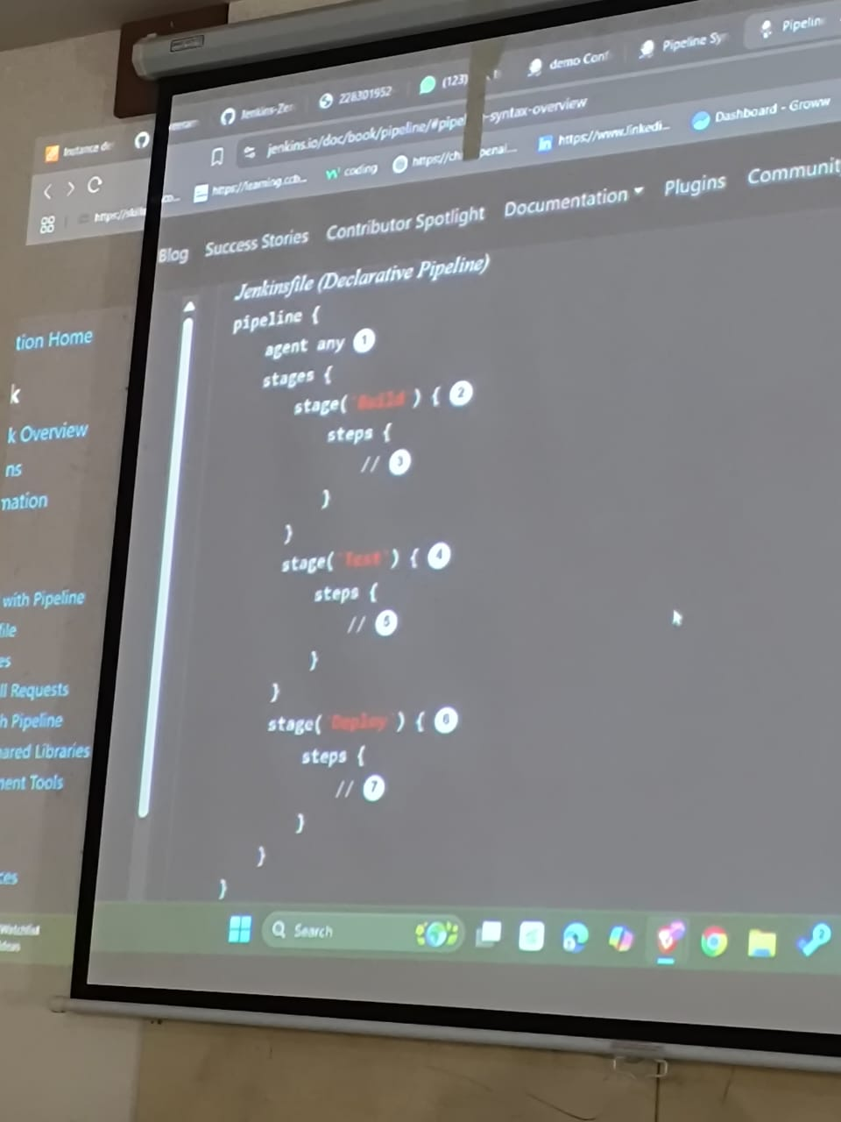**Refer the recorded video for todays topic.**

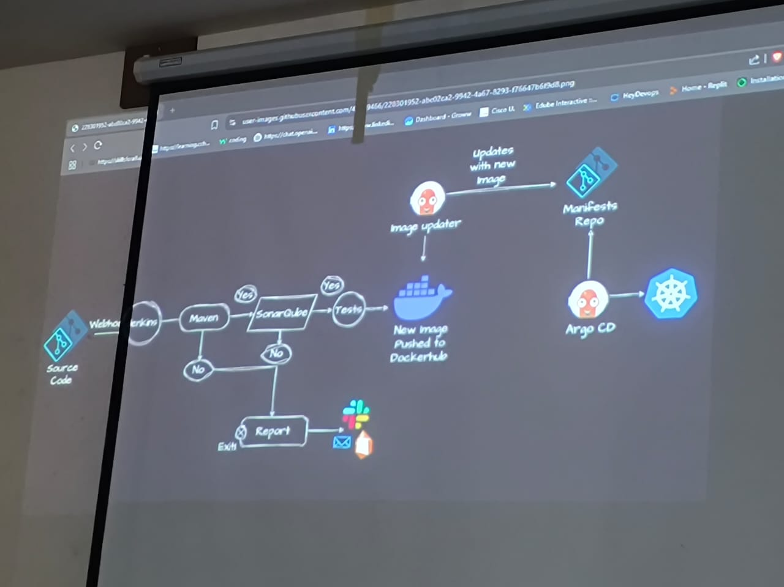

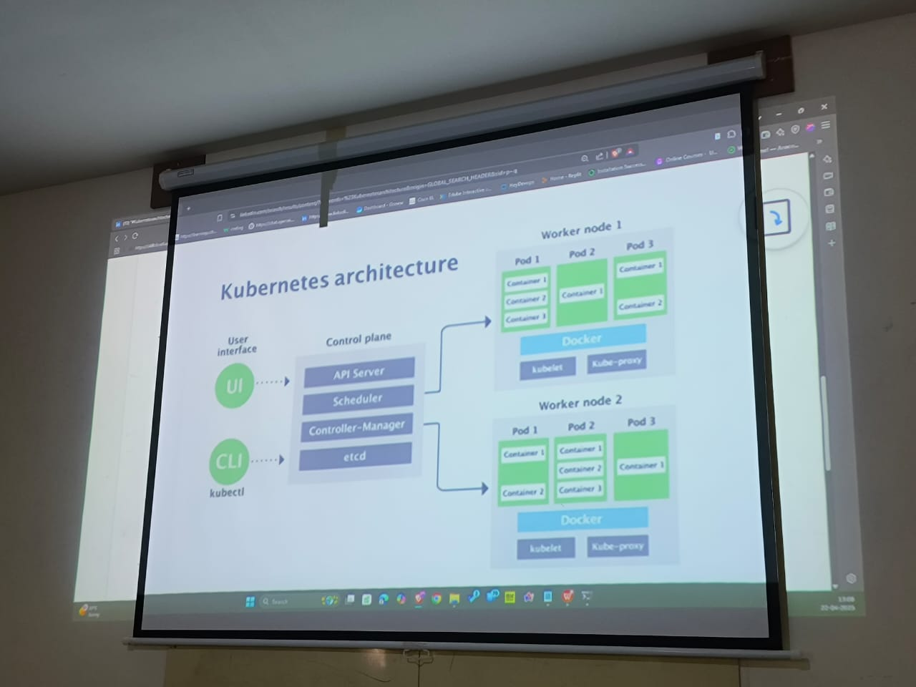

Interview questions

SQL

1. Explain different types of joins
2. Discuss stored procedures ,sql server and their benefits
3. How do implement transactions in sql server
4. Explain normalization in database design and its importance
5. What are differtent types of in sql server and when to use them.
6. Discuss security considerations when working with databases
7. How do you implement and manage Database migration in dotnet application
8. Explain EF and its role in data acess
9. Discuss different approaches to data acess in dotnet
10. How do you optimize database queries for performance

**Cloud and devops:**

1. Explain different cloud computing models
2. Discuss the benefits of using both Microsoft azure and aws for dotnet applications
3. What are the azure app service and azure functions and their use cases
4. Explain azure cosmos db,and how it compares to sql server
5. Discuss Azure active directory and its
6. What are azure storage services and how do you use them
7. Explain azure and aws devops tools and their functionalities
8. Discuss ci/cd in dotnet application
9. How do you implement login and monitoring for dotnet applications in azure
10. Explain the best practices for dot net applicaations to azure or aws.
11. Discuss your experience with any Microsoft
12. How do you approach performance optimization in development process